
Tylers Green First School Governors Newsletter
School Road, Tylers Green, Buckinghamshire HP10 8EF
W: tylersgreenfirst.co.uk T: 01494 813201 @: office@tgfs.org.uk

February 2025

Dear Parents and Carers,
We hope this newsletter finds you all well. It has been a busy and exciting time at the school and there are lots of updates to share.

OFSTED VISIT
Firstly, the biggest news since our last newsletter is the Ofsted inspection which happened in November. After spending two days in the school speaking to pupils, parents, staff and governors, the Inspector was highly complimentary about the school.
The inspector concluded, “Tylers Green First School has a lovely, warm and welcoming feel. There is a strong sense of community, both within the school and beyond”. He also added, “Pupils are happy and value the high level of support and care they receive from their teachers. Pupils are well prepared for the next stage of their education and, overall, achieve well”.
We are in the top 20% of primary schools in the county for academic results and the Inspector was also very impressed with the school’s SEND provision. There are lots of results on the school website which reflect how the children are making great progress in their learning. This includes:
- 81.7% of reception children achieve a good level of development. That compares the 72% across Buckinghamshire.
- 91.7% of Year 1 children passed the phonics check compared to 81% across the county
- It’s a similar picture with Year 2 where 82% achieved expected or higher in reading and 86% in maths.
Nationally, Ofsted has changed the way it grades schools. We are no longer given a single word label, such as ‘good’. However, the Inspector concluded that the school “has taken effective action to maintain the standards identified at the previous inspection” and in his report only made one suggestion on where the school can improve, adding that “curriculum thinking is not as well developed in a few subjects”. These subjects were Science, History and Geography all of which are covered in our school development plan. There is a wealth of information on our curriculum on the school website, and the teachers post all their updates to this. Please check the website and feel free to ask the teachers any questions about our curriculum.
We would like to congratulate the school on securing a brilliant Ofsted report, which is on the school’s website, if you would like to have read in more detail.

GOVERNOR UPDATES

We also have some updates to our Governing board to share.
Our current Chair, Mark Patterson, will be stepping down in March after four years with us. Kathryn Beevers and Esther Pilgerstorfer will be taking over as co-Chairs whilst we recruit a new Chair.
Laura Yeo is becoming our Literacy Governor, Matt Swansbury is our Numeracy Governor and Miss Anderson our Staff Governor.
A reminder that Saj Khan is our Safeguarding Governor and Amy Cunningham looks after SEN, Pupil Premium and Sport Premium. They carry out termly visits at the school and report back their observations to the rest of the board.
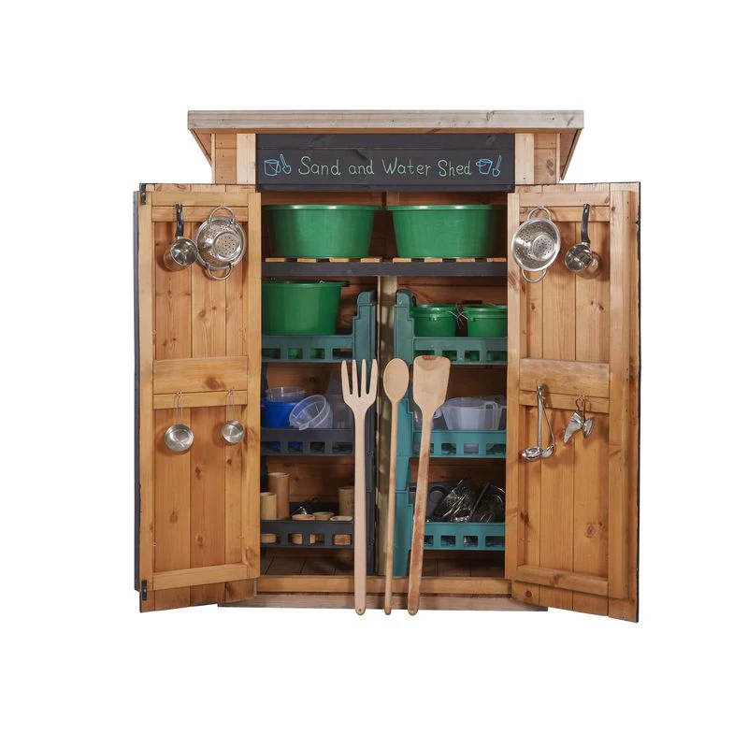
AROUND THE SCHOOL Recently, the school has introduced reading records to Year 1 as a trial. If this proves successful, this will be rolled out to the rest of the school.
We have had some wonderful play equipment funded by a school grant and the PTA delivered to the Reception outdoor area. We hear the children are already enjoying learning with their new resources.
This year the school has also increased the number of Teaching Assistants from eight to ten, which means there is even more help on hand for the children. A grant from ‘Unlock Their Words’ has also been used to give all staff Makaton signing training.

SCHOOL IN THE COMMUNITY


On the penultimate day of term, the Governors helped serve the children’s Christmas lunches. The hall was suitably decorated, and the children all arrived with hats that they had designed and made.
That evening we supported this year’s Children’s Carols on the Common. It was great to see so many of you in attendance. Well done to all the children who sang so beautifully. It really is a magical event.
We are very excited that the school has been selected as the chosen charity for the Penn 7 and Fun Run this year. All funds raised will be put towards refurbishing the Rainbow Room.
GOVERNOR RECRUITMENT
We are currently looking to recruit a new Chair of Governors and a Wellbeing Governor. As we have filled our Parent Governor positions, we are looking to recruit these roles from the wider community. Ideally the Chair will have previous Governor experience or be from an educational background. For the Wellbeing Governor, we are looking for someone with a strong interest and/or experience in mental health and wellbeing. If you know anyone who may be interested in either role please contact the school office; office@tgfs.org.uk
PARENT SURVEY
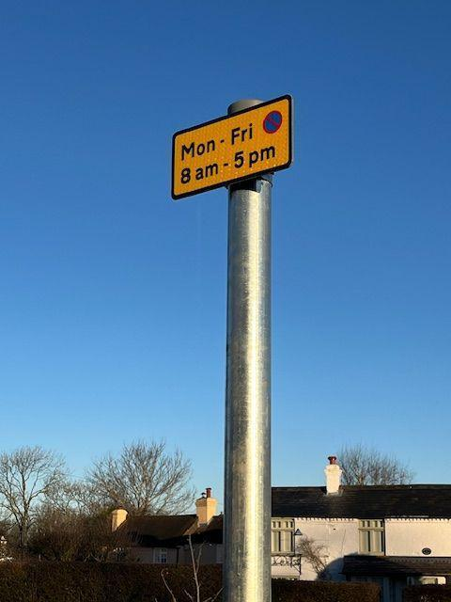
Our next Parent Survey will be sent out in the Spring, please look out for an email later this term.
PARKING
Bucks County Council have recently put up some no parking signs opposite the school - stating no parking or waiting from 8am - 5pm, Monday - Friday. Please do take these seriously as it’s incredibly dangerous for our children to cross the road when so many cars are parked there.
OUR THANKS
We would like to thank Mark Patterson for his commitment and time over the past four years. Mark’s four year term has naturally come to an end, he leaves the school and governing board in a strong position.
Wishing you all a happy half term,
Mark Patterson, Chair

